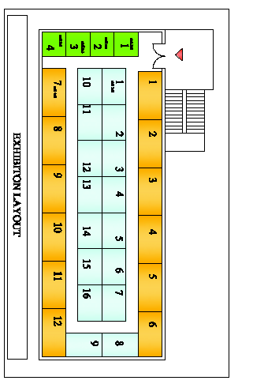

**Stall Sizes**

**2 x 2 sqm**

**3 X 2 sqm**

**4 X 2 sqm**

**2 X 2 Stalls**

**3 X 2 Stalls**

**4 X 2 Stalls**

**Mumbai Education Fair Layout**

**Total Stalls: 32**